SDD Main Menu 3.2

SRS Requirement 3.1.7.1:

Purpose: Describe the appearance and structure of the Main Menu Class.

Description: The Main Menu Class will contain data and modules which are called when the user selects one of five displayed options: Load Mission, Write Mission, Exit, Configuration options, Start Simulation button.

Elements: The Main Menu Class has two elements:

* Data
* Modules

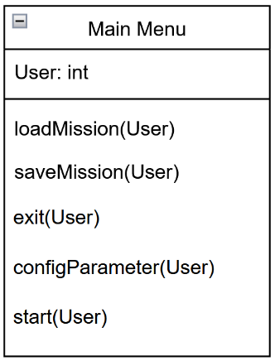 Viewpoint: Class Diagram